**Chapter 4**

**4. Design**

Detail design generally refers to the work of defining and implementing the precise and important elements of a particular project, such as the design of a home services maintenance site. This design aims to improve the user experience and ensure the quality of service provided. (Engineering Product Design, 2024)

**4.1 Design Details**

The home maintenance service is designed to provide comprehensive support to homeowners in managing their property. It typically includes a range of services such as routine maintenance tasks, repairs and renovations, and emergency assistance. Design details often focus on comfort, efficiency, and quality assurance. This may include features such as:

1. Online Booking System: An easy-to-use platform where customers can easily schedule appointments and determine their maintenance needs.
2. Flexible Service Packages: Offering various packages tailored to meet different needs and budgets, from basic maintenance to large-scale renovations.
3. Trained Professionals: Employing skilled and experienced technicians and contractors in various aspects of home maintenance and repair.
4. Transparent Pricing: Providing clear, upfront prices to customers, including estimates of different services and potential additional costs.
5. Quality Assurance: Implement strict quality control procedures to ensure that all work meets high standards and adheres to safety regulations.
6. Rapid Response: Providing quick response times to emergency situations, with service available 24 hours a day, 7 days a week for urgent repairs.
7. Regular Inspections: Perform regular inspections to identify potential problems early and prevent costly repairs in the future.
8. Customer Feedback System: Collect feedback from customers to continually improve service quality and address any concerns immediately.
9. Insurance and Warranty: Providing insurance coverage for both service providers and customers, in addition to guarantees for workmanship and materials used.

**4.2 Flow Chart**

**4.3 Context Diagram:**

Context Diagram:

This graphic serves a broad purpose by showing how services are launched and the external factors that impact them, without drawing attention to internal project components or processes. It aids in comprehending the overall goal of the system and demonstrates how to design a new system, as seen in the graphic. It conveys the degree to which each home maintenance service is supplied by the manager, staff, and maintenance.

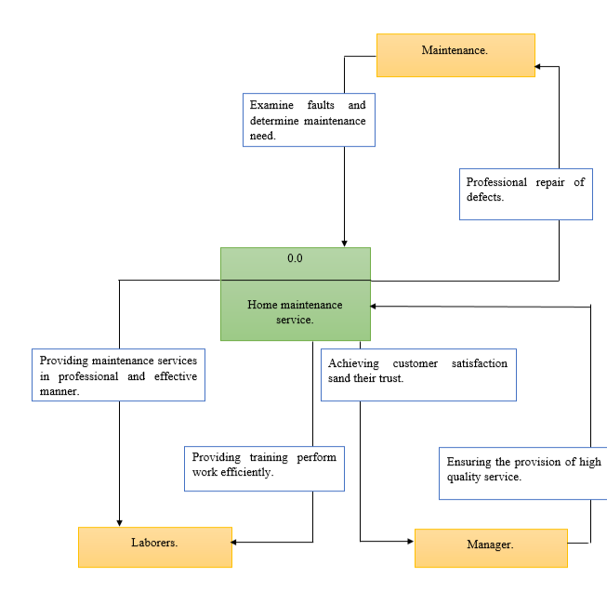

**4.4 Case / Use case diagram**

